We will refer to the playwright documentation: https://playwright.dev/java/docs/intro
We will do the following:
- Install JDK
- Configure Maven
- Download eclipse
Create a new Maven project.
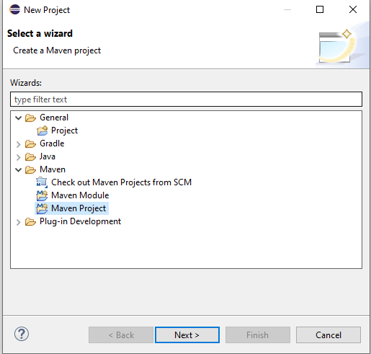
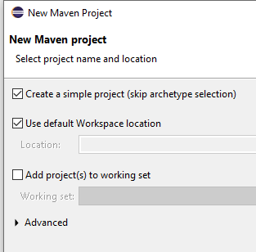
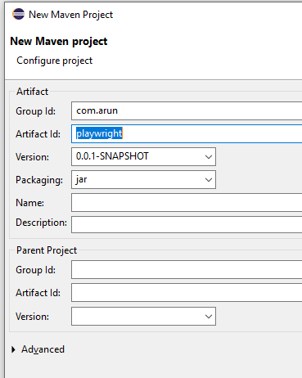
Configure POM.xml
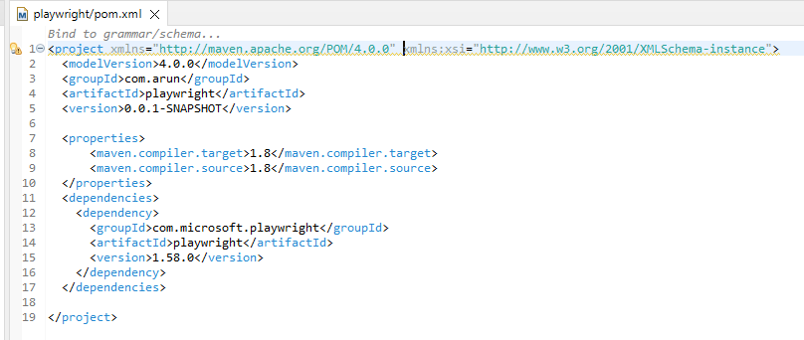
Create a new Java file:
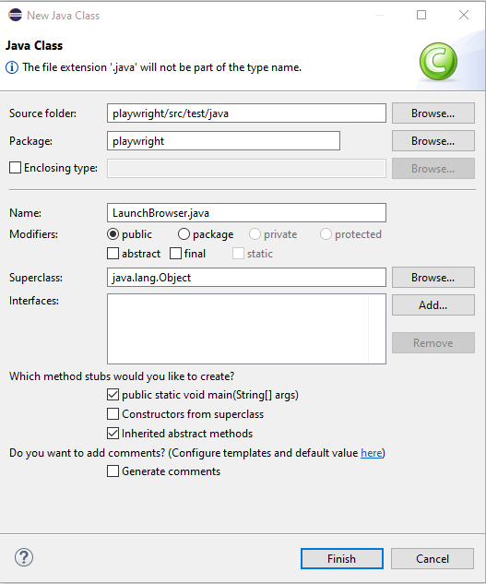
We will create a playwright instance.
Then we create a browser instance using the browser instance.
Then we create a page instance using the browser object.
Using page object we will launch the URL.
Finally we will create the page instance and the playwright instance.
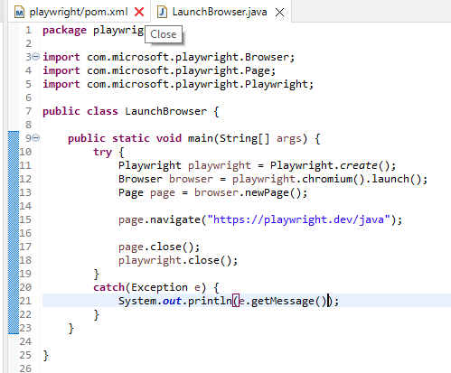
Browser will launch in headless mode.
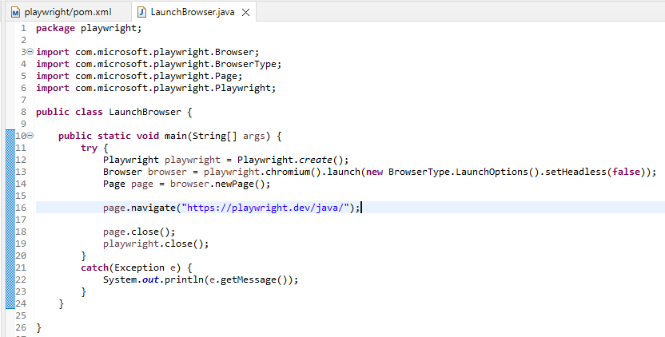

Maximizing Window:
To maximize the window we need the screen size.
https://whatismyviewport.com/#:~:text=Viewport%20size%20refers%20to%20the,operating%20system%2C%20etc.).

Rather than using the browser object we will use the browser context object.
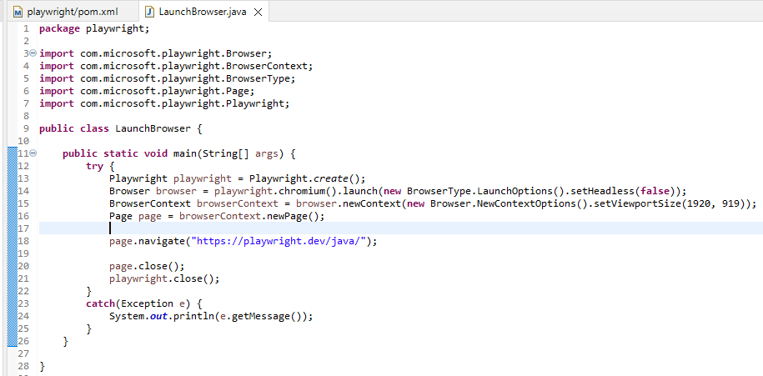
Still we see browser is not getting the full screen.
We need to calculate view port size at the run time. We need to use the dimension class.
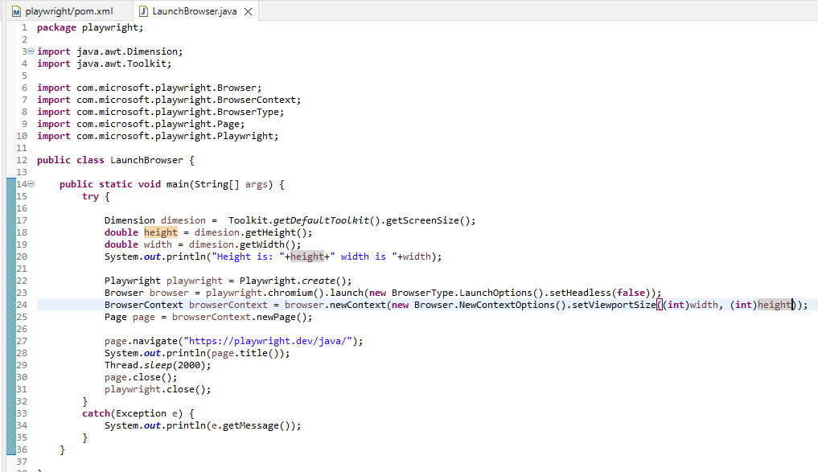
We can also launch execution in edge browser.
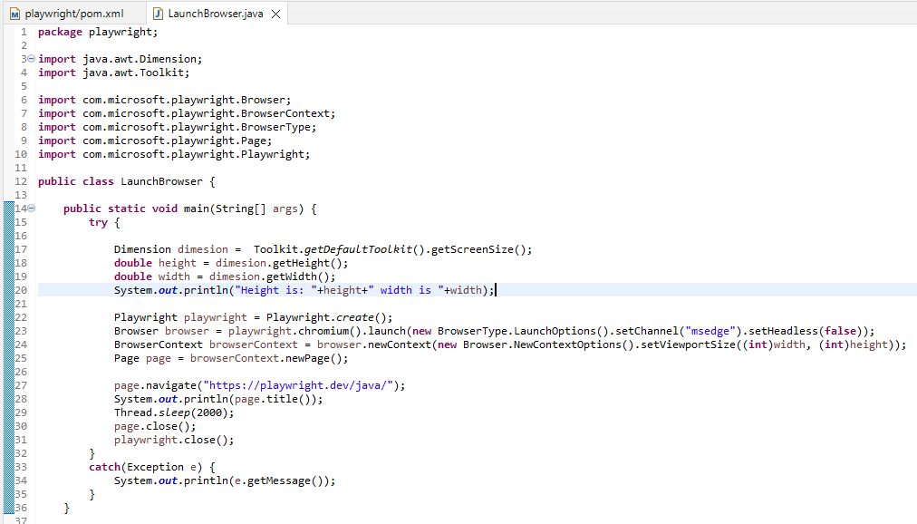
We can also maximize the browser by passing arguments.

